ITEC 3200 SQL Homework Assignment, Part I

Instructions: Use the Animal Shelter database and MySQL to write the queries to answer the following questions. you may not use any information that’s not given to you in the problem. For example, if the quesetion says to list the animals cared for by Carol Knotts, you cannot look up the Vol_id for Carol Knotts and plug that into the query. You can only use the name Carol Knotts.

Make sure to number the queries (HW1, HW2, etc.) and that you put the queries IN ORDER. Save in one SQL script, named Homework1.

Use comments to separate the queries. A comment is two dashes followed by a space. (don’t forget the space.) For example:

-- HW1
SELECT statement 1

-- HW2
SELECT statement 2

Etc..

Submit Homework1 to the Dropbox in D2L.

- Write a query that gives the animal’s name, age, and arrival date. Limit the results to female animals and put in ascending order by animal name. Give column headings as Name, Age, and Arrival Date, respectively.
- What is the ID and name of the animal(s) who arrived on ‘2018-01-02’? Note that you will have to use single quotes around the date, and use the format ‘YYYY-MM-DD’. Give column headings as ID and Animal Name.
- List the animal ID and names for those male animals who are breed number 10. Order by the animal ID. The column headings will be ID and Animal Name, respectively.
- Who is Coco’s volunteer? Write the answer in the format: FirstName Lastname. (concatenate the first and last name.) Name the column heading ‘Coco Volunteer’.
- Select the animal name, breed name. Then find the average low and high weights for the breed. For example, the average low weight would average the male_lo_weight and the female_lo_weight. (Do not use the average function—calculate the average by adding the two values, and dividing by 2). Order by the Average high weight descending. The first few records are shown below (there are 23 rows in the result set):
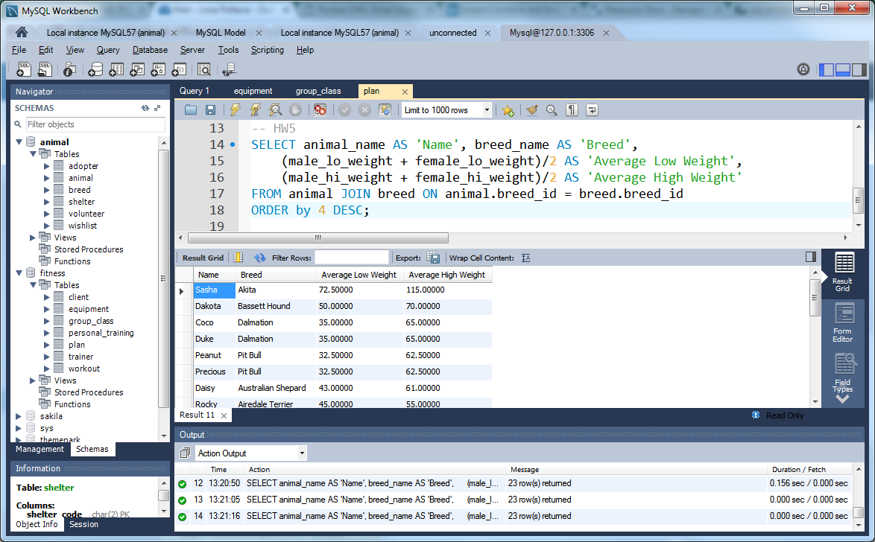
- Select the name of the adopters and what is on their wishlist, that is, the desired breed and age for what type of animal that they wish for. Only include those who would like to have cats. Order by their first name. You should format your results as shown below:
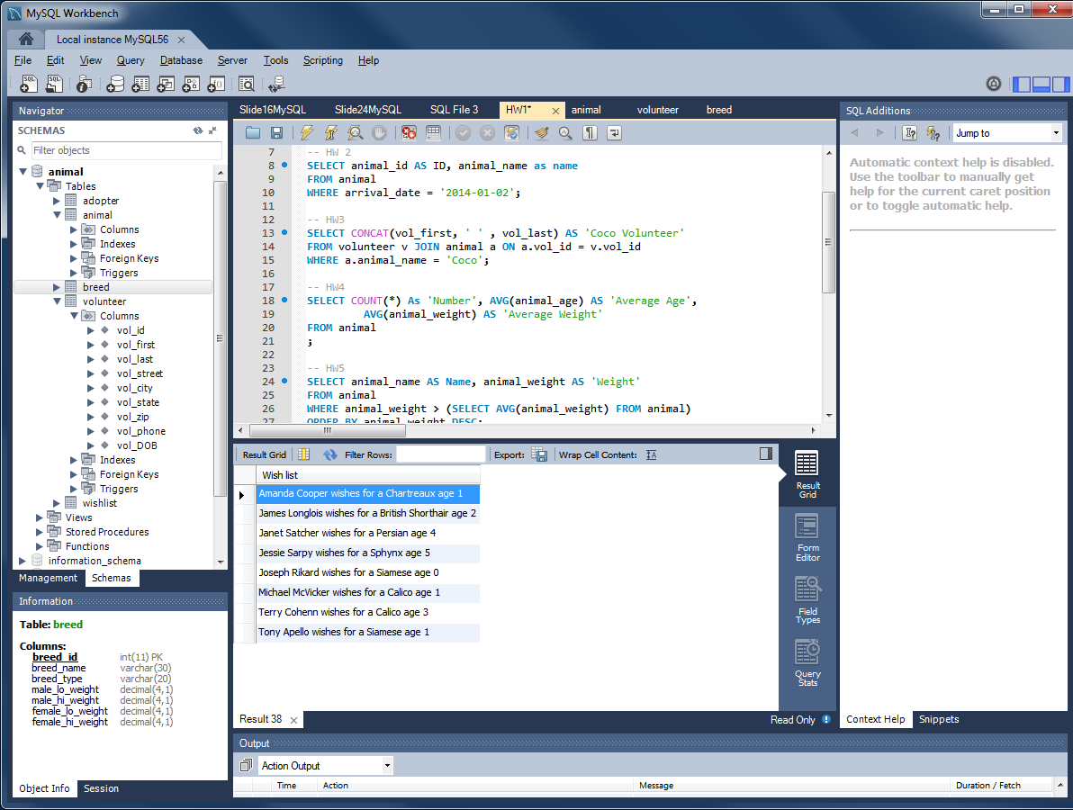
- How many volunteers are there? Label the answer “Number of Volunteers”.
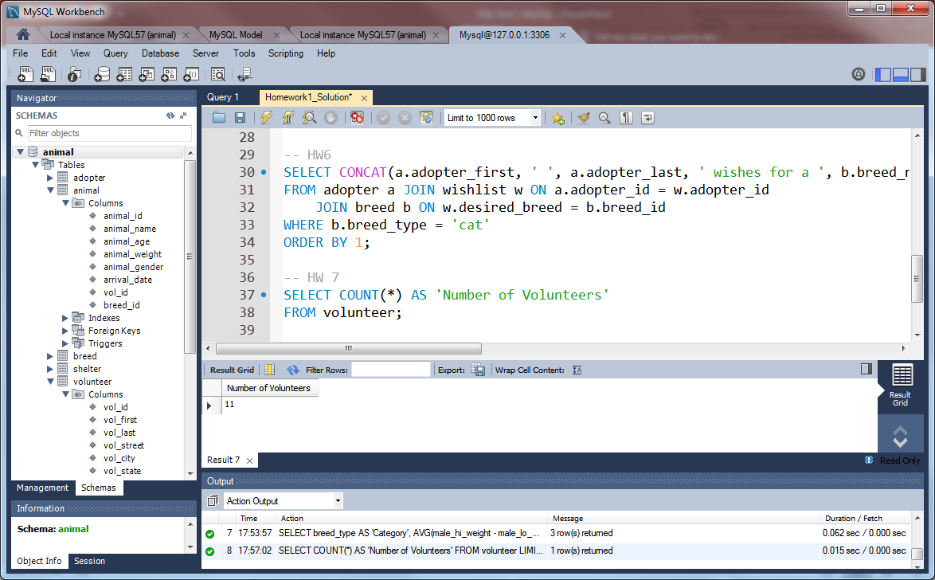
- List the type of breed, the largest male weight, and the largest female weight (Hint: Use the MAX function on the hi_weight). Format column headings as shown below, and sort by the type of breed:
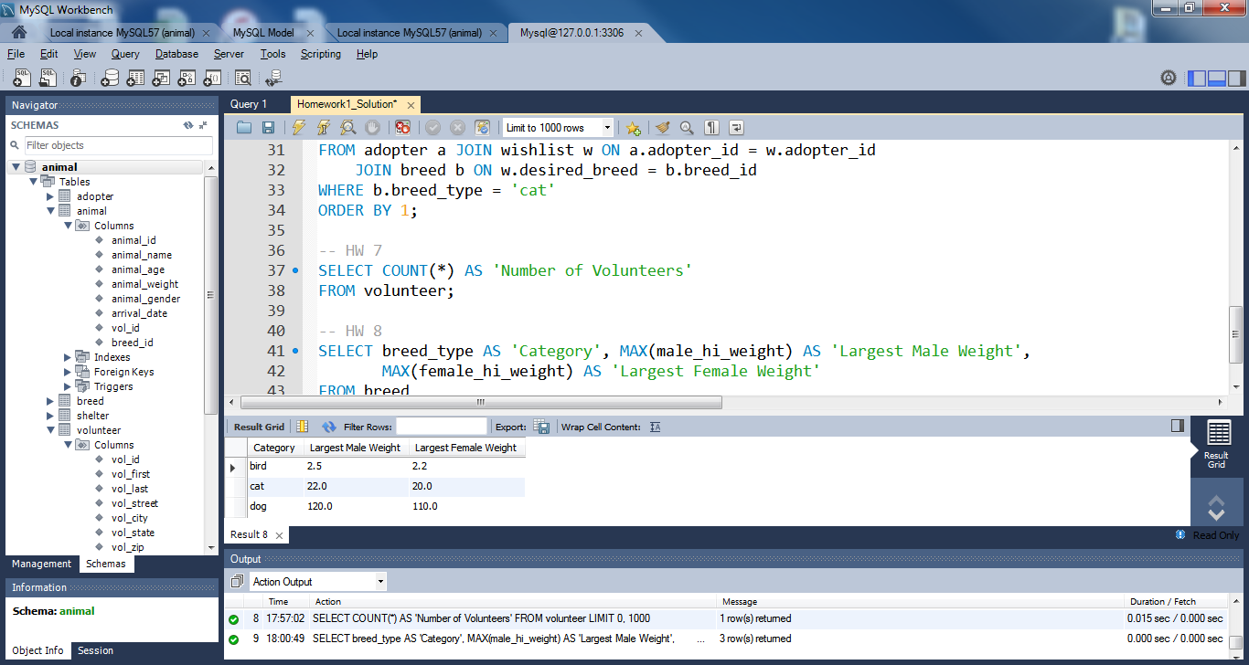

HW9. List all clients who live in the same zip code as Jim Rivera. Do not look up Jim’s zip code yourself—use a subquery. Order by client ID.
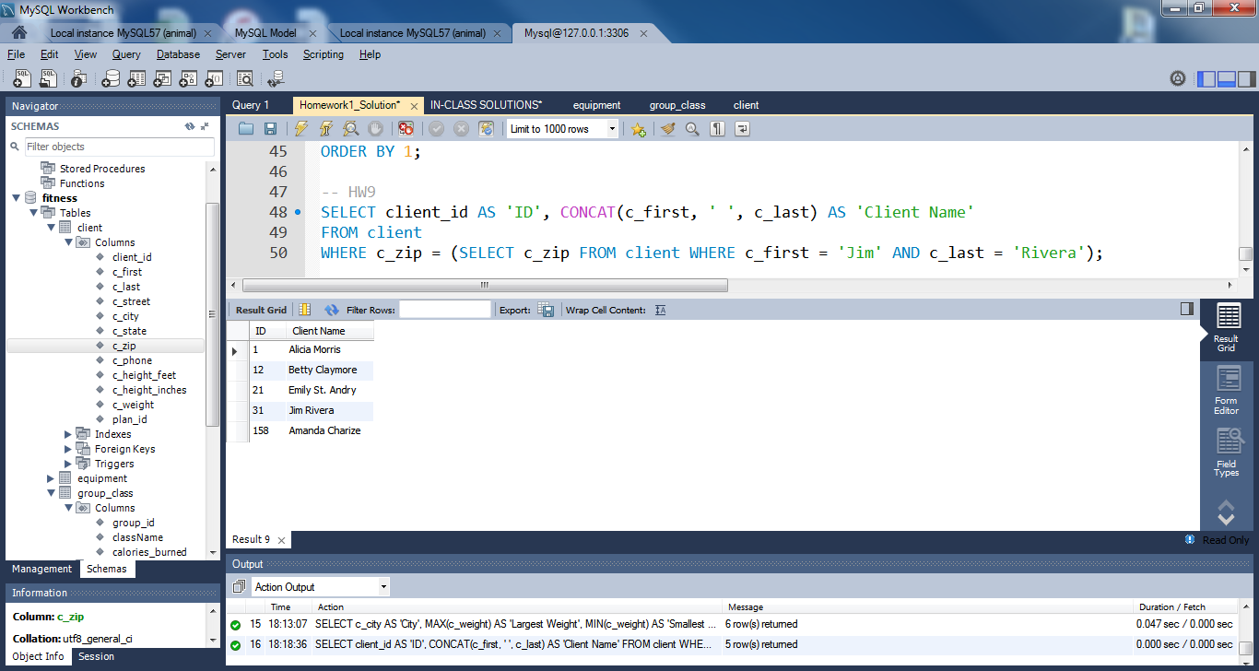
HW10. List the 2 types of workouts (Group (G) or Personal (P)) from the workout table and the average length of the workout. Use the ROUND function to show the average length as a whole number, as shown below. Order by Average Length descending.
